Jonathan Nusantara (jan265) and Jiaxuan Su (js3596)

**Project Definition:**

We are first inspired on how drones are able to track the user as they record a video, providing a convenient experience for the user. We then thought about having a ground robot that has a similar tracking capability, where it will be able to carry things around and also operate indoors. The user will be able to seamlessly interact with the robot using finger gestures. This robot can be installed on shopping carts in grocery stores or luggage carts in the airport. Having this robot will allow the user to conserve their energy (from carrying items or pushing carts) and also focus their attention on other things, such as looking for the things they wanted to get from the grocery racks.

As an initial prototype, we have replaced the human with a ball for the tracking program for simplicity given the time constraints. The robot will utilize the live video feed from the camera and perform Computer Vision to recognize the ball and hand gestures. The robot will be tracking the ball and steer towards the ball until it is close to it. Using hand gestures, the user will be able to start and stop the tracking program, and also to manually control the movement of the robot. This is done by showing hand gestures towards the camera, showing one to five fingers which represent different commands. The PiTFT will display the current mode and provide “start” and “stop” buttons for the user. The outline of the robot’s capabilities is as below:

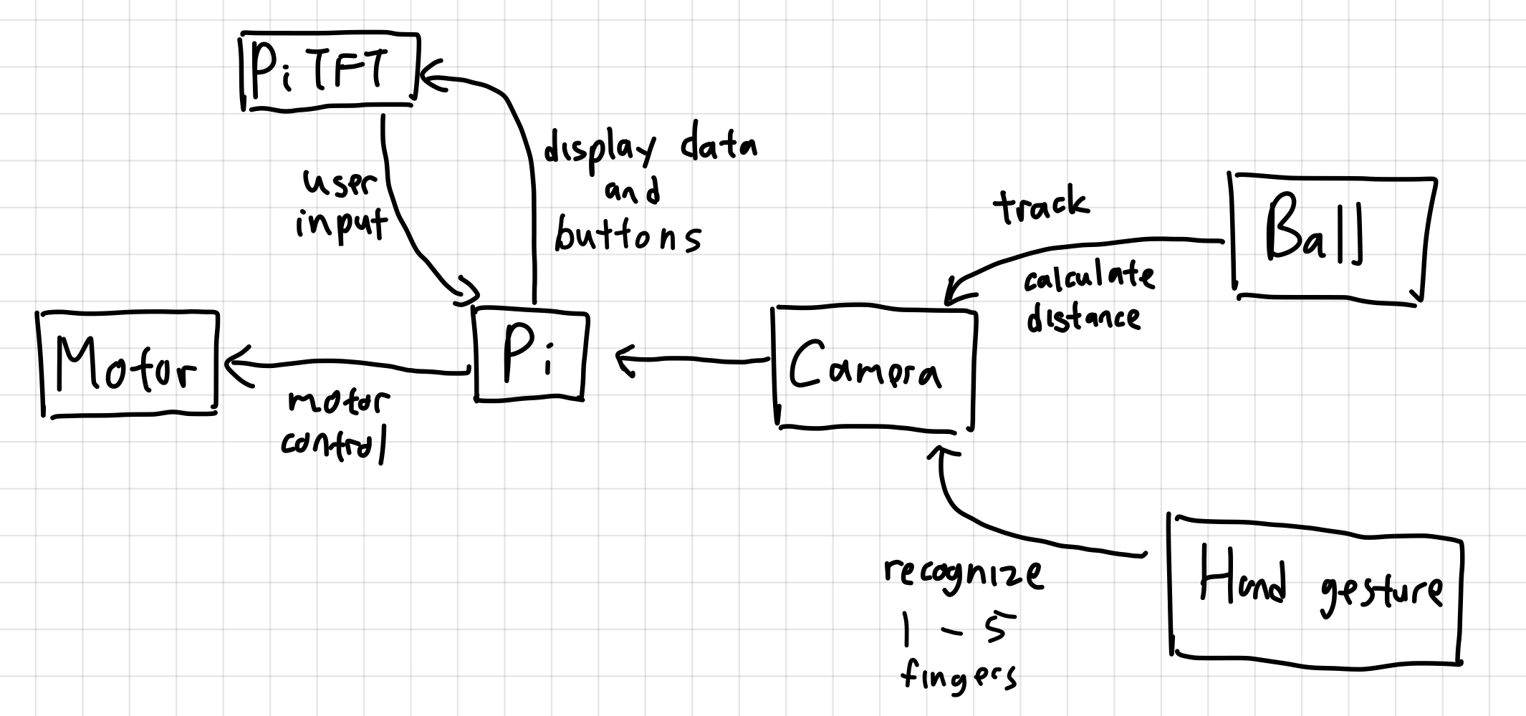

Figure 1 - Outline of the robot’s capabilities and how different components interact with each other.

Hand gestures: The robot will use the PiCamera and perform computer vision to recognize hand gestures using OpenCV. Below are the list of hand gestures to recognize and their meaning:

* 1 finger: The robot will be put into the “stop” mode and will stop moving.
* 2 fingers: The robot will be put into the “tracking” mode and will start to track the ball and autonomously steer itself.
* 3 fingers: The robot will be manually controlled to slowly move forward as long as this finger gesture is detected.
* 4 fingers: The robot will be manually controlled to slowly move backward as long as this finger gesture is detected.
* 5 fingers: The robot will be manually controlled to slowly rotate clockwise as long as this finger gesture is detected.

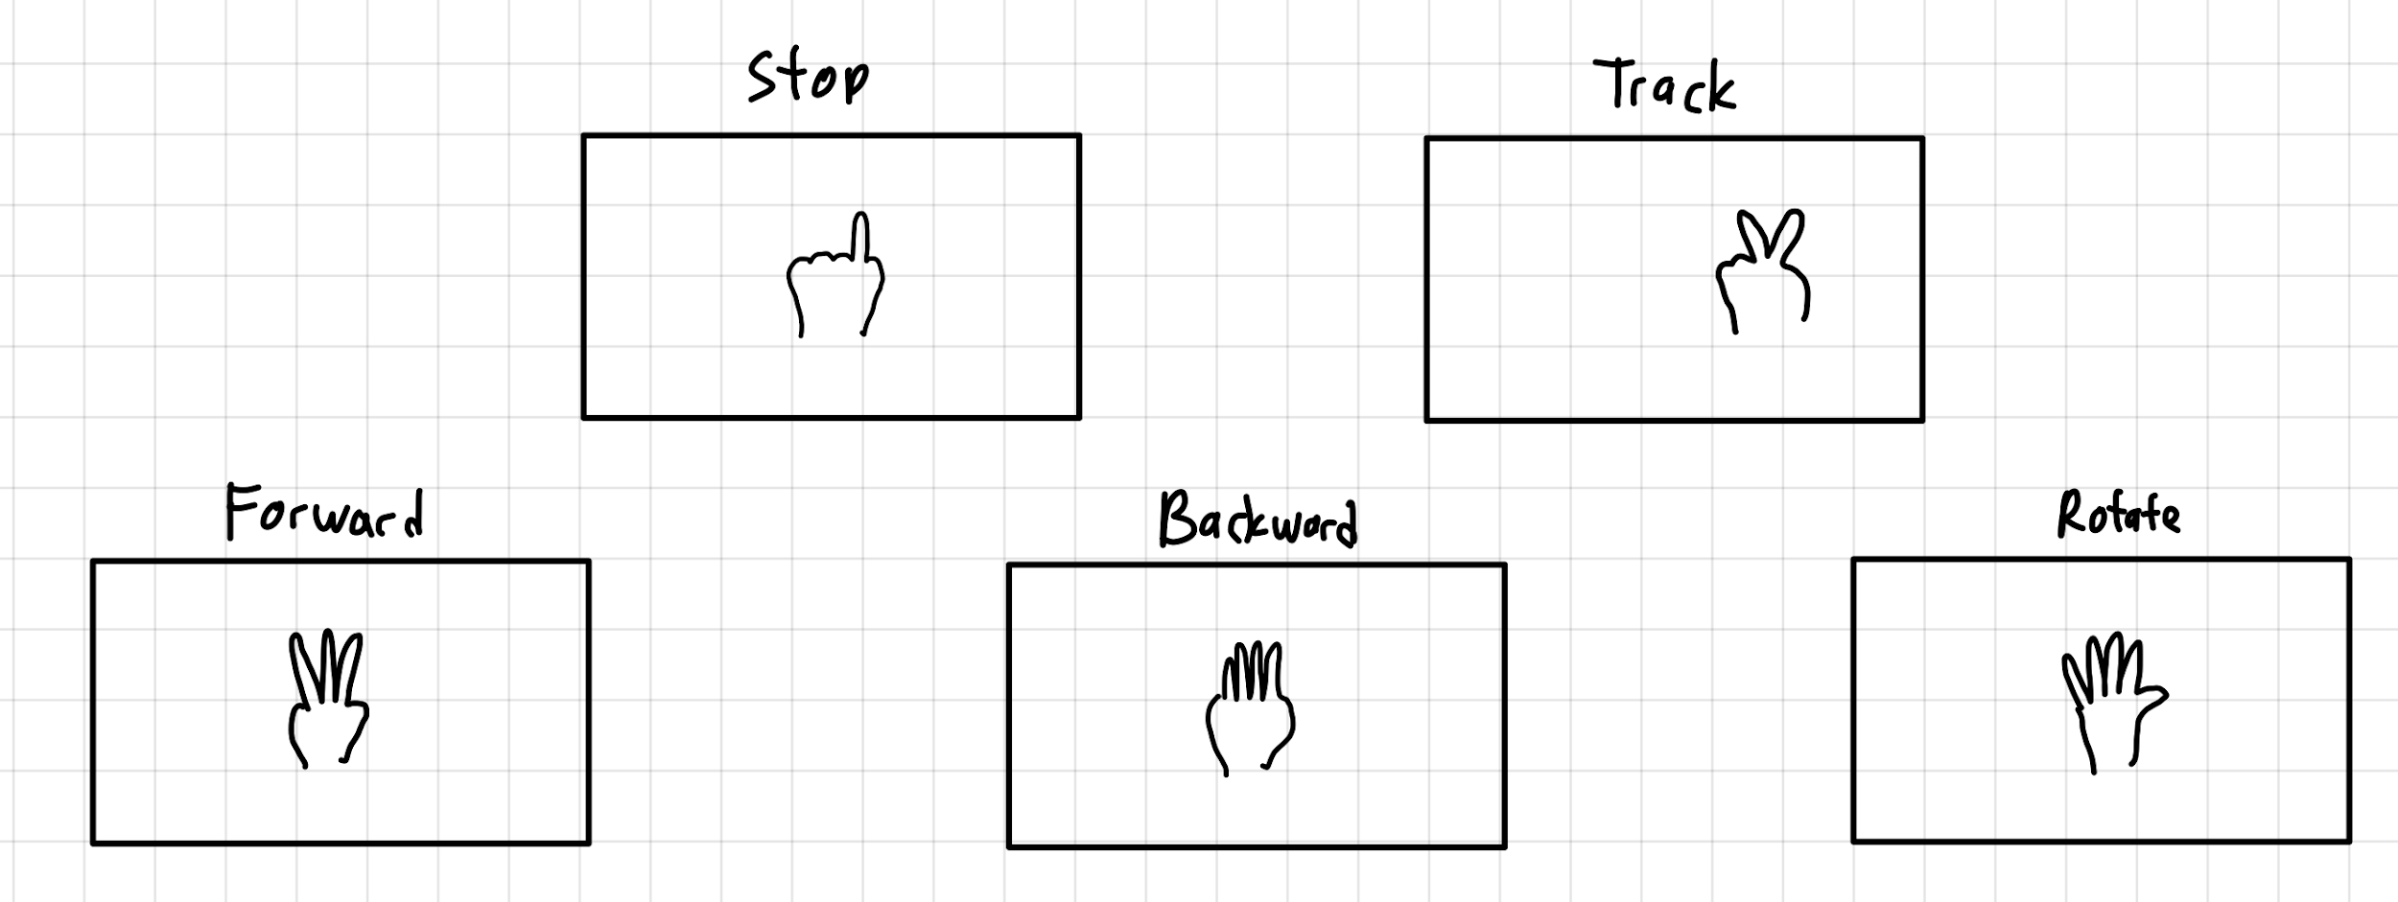

Figure 2 - The different finger gestures and their corresponding meaning.

Robot states:

* “Stop” state: In this state, the robot will not be moving. The robot will not be tracking the ball, but will be looking for hand gestures viewed from the camera. This is the default state of the robot when the program first starts for safety reasons. The user can choose to enter this state by 1-finger hand gesture or “stop” button on PiTFT.
* “Tracking” state: In this state, the robot will autonomously track and follow the ball. When the ball is not detected, the robot will slowly rotate clockwise 5 times to look for the ball and will return to “stop” state when the ball is not located. The user can enter this state by 2-fingers hand gesture or “start” button on PiTFT.
* “Forward” state: In this state, the robot will slowly move forward as long as the user is showing 3-fingers gesture. It will return to “stop” state once the user stops showing the gesture.
* “Backward” state: In this state, the robot will slowly move backward as long as the user is showing 4-fingers gesture. It will return to “stop” state once the user stops showing the gesture.
* “Rotate” state: In this state, the robot will slowly rotate clockwise as long as the user is showing 5-fingers gesture. It will return to “stop” state once the user stops showing the gesture.

Tracking program:

The robot will detect the ball by performing Computer Vision on the live video feed from the PiCamera. The distance of the robot to the ball may be calculated based on the size of the ball that is detected from the video, the actual size of the ball, and the camera’s focal length. When the ball is far away from the robot, the robot will move forward towards the ball. When the ball is too close to the robot, the robot will move backward away from the ball. The goal is to have the robot stay close to the ball, but to give it some personal space (as the human will eventually replace the ball in the system). The robot will steer left and right based on the location of the ball on the video detected by the camera, with the goal of having the ball stay in the middle of the recorded video feed. When no ball is detected, the robot will slowly rotate clockwise at most 5 times to look for the ball. It will return to “stop” state if the ball is not found.

The figure below shows the control that will happen when balls are detected different from ideal:

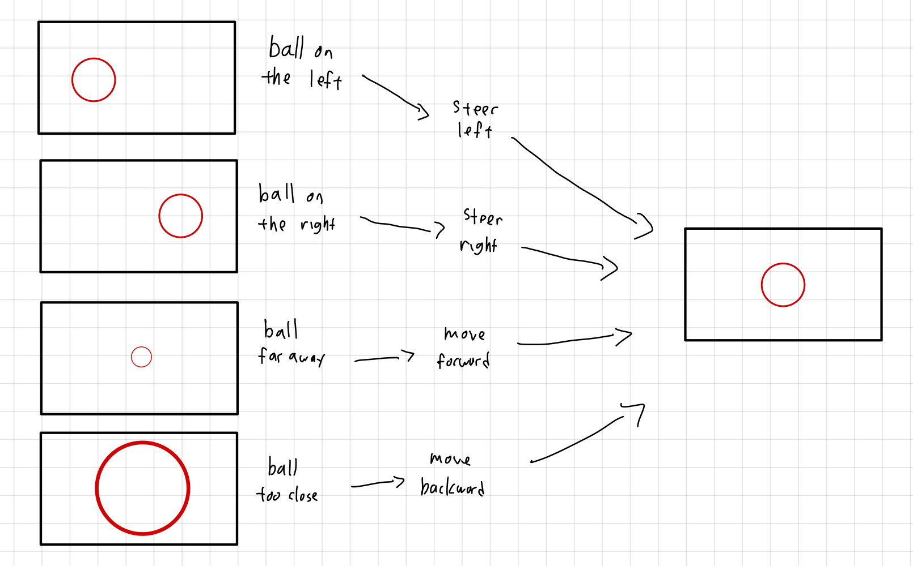

Figure 3 - A diagram showing the motor movement as balls are viewed by the camera.

**Goals of the project:**

* The robot shall track the ball and move to follow the ball and steer accordingly.
* The robot shall move back if the ball gets too close to the robot.
* The robot shall stop moving when the ball is within a close range of distance to the robot.
* If the ball is no longer detected, the robot shall rotate slowly 360 degrees 5 times to look for the ball. If the ball is not found, the robot shall stop moving.
* The robot shall detect hand gestures of 1 to 5 as user input.
* The PiTFT shall display the last recorded command from the user and display the “start” and “stop” button as user input.
* Stretch goal: The robot shall speed up when it is far away from the ball and slow down when it is close.
* Stretch goal: The PiTFT shall display the distance between the robot and the ball.

**Schedule:**

|  |  |
| --- | --- |
| **Week** | **Tasks** |
| 11/16 | Prepare motor control program and PiTFT interactive display.  Perform object detection on the ball using OpenCV. |
| 11/23 | Integrate camera to robot for ball tracking where the robot will move to follow the ball.  Design the autonomous tracking program.  Perform image detection on finger gestures using OpenCV. |
| 11/30 | Integrate the finger gestures detection program to the robot’s main program and have the robot to move based on the finger gestures. |
| 12/07 | Integrated testing |
| 12/14 | Lab report and further debugging. |

**Elements of the projects:**

Hardware:

* Raspberry Pi 4 as the microcontroller for the robot, which will run and control the programs.
* PiTFT for display and user inputs.
* Portable battery pack to power up the microcontroller.
* The robot base from lab 3 will be used, which includes the chassis, 2 motors, motor controller, and battery.
* PiCamera for live video feed from the front of the robot.

Software:

* The programs will be in Python programming language.
* OpenCV library will be used for the Computer Vision software.

This project uses Raspberry Pi as the microprocessor. It receives the input from a camera and processes the image to give commands to the robot. The Raspberry Pi is dedicated to carry out the software functions while the robot is designed to perform the hardware functions. The whole system is designed to implement an object tracking function similar to the existing function of drones on a ground-based robot. The system will perform the operation automatically and independently in real-time. It can also process human inputs to perform specific tasks. This project contains software and hardware and is designed to perform some specific functions. It meets all the definitions of an embedded system.

**Parts list:**

|  |  |  |
| --- | --- | --- |
| **Parts** | **Price** | **Website** |
| Raspberry Pi 4 | $35 | <https://www.raspberrypi.org/products/raspberry-pi-4-model-b/?resellerType=home> |
| Adafruit PiTFT | $35 | <https://www.adafruit.com/product/1601> |
| Lab 3 robot base | - | Provided for the course |
| Raspberry Pi camera | $25 | <https://www.raspberrypi.org/products/camera-module-v2/?resellerType=home> |
| Battery pack | - | Provided for the course |

Despite the price listed above, all of the parts are included from the ECE 5725 course, except for the Raspberry Pi Camera that is loaned from Professor. We spent $0 for the project.

**Final project demo:**

The final prototype would be a lab 3 robot integrated with the camera functions. The robot will recognize a ball rolling on the ground and follow the ball while it is moving. The robot will be able to speed up while the ball is far away or moving fast, and slow down when the ball is close or moving slow. The direction of the ball will be changed manually or by bouncing into objects. The robot should be able to change direction as the moving direction of the ball has changed. The robot will also be controlled by hand gestures. The robot would be able to recognize 1 to 5 fingers and perform the corresponding functions as defined in the project definition section. To demonstrate the functions of the robot, it will be placed on the ground and wait for command from hand gestures. Once the start command is given, the robot will start to rotate and look for the rolling ball. A ball will be rolling into the view of the camera from a random direction. Once the robot could successfully track the ball, the direction of the ball will be changed by pushing the ball to another direction. The function of changing direction will also be demonstrated by letting the ball bounce into objects. Then the ‘stop’ command will be given to the robot by hand gestures to stop the tracking function. After the autonomous tracking is stopped, hand gestures will be used to control the robot manually. Finally, the robot will be set back to tracking mode by corresponding hand gesture. While the robot is operating, the piTFT should display a start and stop button. By pressing the button, the robot should be stopped from or resume to the tracking program.

**Week 2 progress report:**

During the past week, we have solidified the project’s goals and definitions. Our decisions and plans are clearly explained in this report. We looked through the different projects in the ECE 5725 course website to find inspirations on how other teams have used the Computer Vision for object recognition. We also started to look into the OpenCV documentation and will start installing and exploring it after this week’s meeting.

Since it is still very early in the project, we have not encountered any major problems. There has just been plenty of discussions on the project’s goals and definitions. We have been discussing additional features since the previous meeting and we felt that we may have too many features to implement given the amount of time we have. We would love to receive feedback from our Professor and TAs. Another thing that we are debating about is on how reliable the robot is to speed up and slow down. Something that we have witnessed from lab 3 is that the robot will only operate well in a small range of PWM duty cycle, where at dc < 50 the motor is too weak to move the robot while at dc > 90 the robot is moving too fast.

For this week, we will start to work on the motor control program by using the template from Lab 3, as well as programming the PiTFT user interface. We will also start to program the object recognition program to detect the ball. Hopefully everything will go fairly well and we can even start detecting finger gestures or start tracking the ball with the robot. Overall, we are on track with our initial plan and future plans. We will continue working on this project.